 |  | Welcome to Cub Scouts!
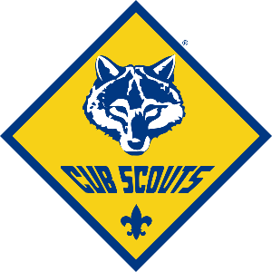 | Pack 123, Your Town USA
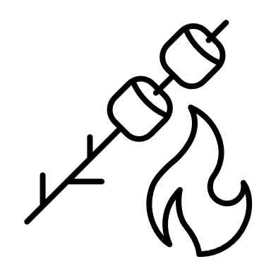  What is Cub Scouts?  Cub Scouting is fun for the whole family. In Scouting, boys and girls start with their best right now selves and grow into their very best future selves. It’s fun, hands-on learning and achievement that puts kids in the middle of the action and prepares them for today – and for life.  Cub Scouts have fun and go places with their family, friends, and neighbors. They earn awards with requirements that develop self-responsibility, confidence, and willingness to help others. |  |  |  |  | When and where do we meet?  Cub Scout dens (grade-specific) meet about twice a month to work on adventures. Cub Scout Packs (all dens together) meet once a month to showcase activities and receive awards or recognition in front of loved ones.  Our Pack meets at location on day of month. Dens can meet wherever the group decides – school, church, park, or even someone’s house. |  |  | What do we do?  Cub Scouts go camping, build rockets, eat s'mores, and make friends. Plus, there's the pinnacle of most Cub Scout years - the Pinewood Derby! Cub Scouts earn recognition while doing fun activities with their family, using a handbook as their guide. Get to know your child's friends and their families as part of a den made up of similar-age youth.
What’s the cost?

The one-time new member joining fee is $25. The yearly membership fee sent to National for Cub Scouts is $72 per year and is pro-rated if a Scout joins after the 1st of the year. Pack Supply dues are $12 per year. Scout Life (an optional but very cool magazine) is $12 per year. These fees (outside of the new member fee) are prorated if you join after Jan 1st. Other costs for uniforms, activities, camp, etc. are not included in the membership fee. Scouts is a year-round program. Fundraising programs (like selling popcorn) are available to help keep costs low for families.

What do I need to buy? |  |  | - Uniform ($30)  - Lion shirt for Kindergarteners, Blue Uniform for Tigers to Webelos I and Tan Uniform for AOL (Arrow of Light) or Webelos 2  - Buy it big so they can grow into it over the years.  - Hat and Neckerchief ($30)  - The Scout Shop will help you get the right ones.  - Patches (~ $10)  - Council, Pack Number, Crest, Flag, Den # (optional)  - The Scout Shop will help you get the right ones  - Handbook ($17)  - Each Den (Lion, Tiger, Wolf, Bear, Webelos) has their own book.  - Needed for the first Den meeting, if possible.  - Class B T-shirt ($15+)  - OPTIONAL but is handy for events that don’t require full uniform like Campouts.  - Purchased from us. They have our Pack logo on them. Scouts love them!  There is also a uniform closet full of gently used uniform parts. Please feel free to take advantage of this instead of buying new.
Where do I buy these items?  The Scout Shop is located at 411 West Boy Scout Way in Spokane, WA. They are open Monday – Friday, 9-5. If you cannot make it there in person, you can order online at https://www.nwscouts.org/spokane-national-shop and they will ship it to you for a small cost.  This is also where the uniform closet is located. You will need to inquire at the Service Center, located down the hallway from the Scout Shop. The staff at the front desk will take you downstairs to look through the uniform closet. The Service Center is open Monday – Friday, 10-5. |  |  |  |  |  | What are our Council, District, and Unit details?  We are part of the Inland Northwest Council.  We are in the XXX District.  We are Pack 1234.  What is our Facebook Page?  You can find information about our Council at:  www.facebook.com/InlandNorthwestCouncil  You can find information about our District at:  www.facebook.com/YOURDISTRICTPAGE  You can find information about our Pack at:  www.facebook.com/YOURPACKPAGE
How can a Scout earn money?

Popcorn sales during the month of October is a great experience for Scouts. It teaches them Public Speaking skills, Money Management, and more. A portion of Popcorn sales a Scout sells will be put in that Scout’s account in November and can be reimbursed on anything scouting-related. This could be: BSA Dues, Summer Camp costs, Class B shirts, Hiking Boots, etc.

Camp card sales during the spring are another opportunity to earn money. The cards have discounts for local businesses on them, and Scouts earn $5 for every card sold.

What other fundraisers does your unit do every year?

Ready to join? Here’s your checklist:  - Complete youth application  - Membership dues  - Uniform  - Handbook  - Parent “Power of One” survey  - Follow us on Facebook! |  |  | How can parents get involved?  Cub Scouting engages the family. Working together, you will complete and sign off on the requirements found in the handbook - from doing a magic trick to creating a fire escape plan for the family home. The majority of requirements are completed in meetings, but some may need to be finished up at home with an Akela’s (leaders; which can include the parent when not around other leaders) help.  Scouting is a volunteer-led program. Parents are welcome and encouraged to get involved as a Pack leader or volunteer. Scout leaders have the opportunity to work with youth and their families, improving the community through fun-filled activities that teach values of the Scout Oath and Law. By serving as a leader you can help make a positive difference in the kind of adults Scouts grow into. Scouting uses the 2-deep leadership model for safety which means there is a great need for parent involvement.  Many tools, resources, and training are available to assist volunteers in becoming effective leaders and enjoy their experience.
Questions? Contact our leaders:

Cubmaster | Name | Phone Number | Email
Committee Chair | Name | Phone Number | Email
Tiger Den Leader | Name | Phone Number | Email
Wolf Den Leader | Name | Phone Number | Email
Bear Den Leader | Name | Phone Number | Email
You can add or delete these rows! | Click the table, then click Layout at the top of the page

