- Download and save your Scouting background on your computer
- Sign into the Zoom meeting
- In the upper left corner of the screen, click the green shield icon

- Click the settings wheel in the right of the box that opens

- Go to “Backgrounds and Filters”
- Select the plus icon on the right side

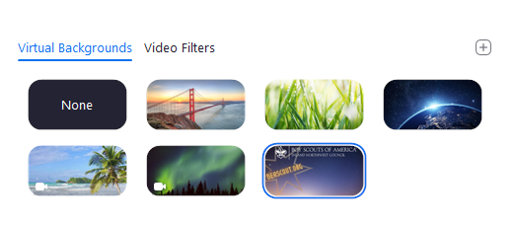
- Select “Add Image”
- Select the background you want from your computer and open
- If the image shows up mirrored, unclick the “Mirror my video” box at the bottom of the screen

- You’re all set and ready to show your Scouting pride!

